**Big data defined**

What **exactly** is big data?

The definition of big data is data that contains greater variety, arriving in increasing volumes and with more velocity. This is also known as the three Vs.

Put simply, big data is larger, more complex data sets, especially from new data sources. These data sets are so voluminous that traditional data processing software just can’t manage them. But these massive volumes of data can be used to address business problems you wouldn’t have been able to tackle before.

## The three Vs of big data

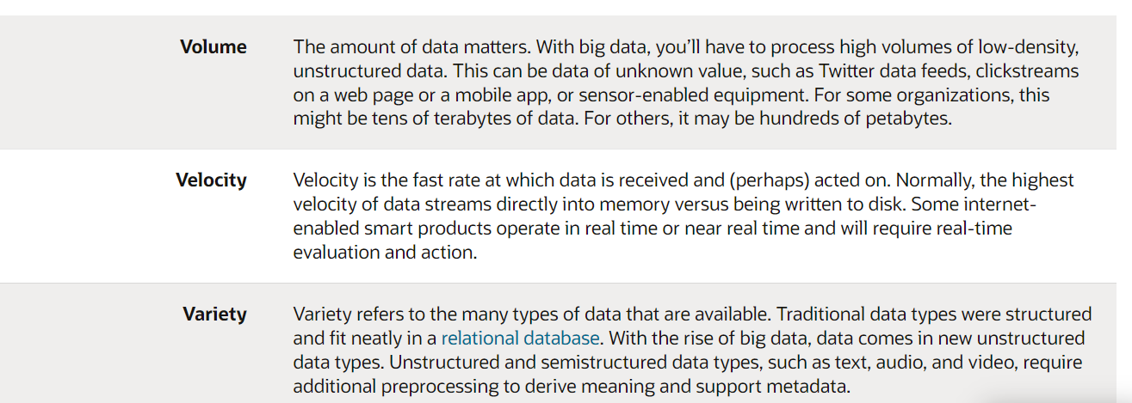

## The history of big data

Although the concept of big data itself is relatively new, the origins of large data sets go back to the 1960s and ‘70s when the world of data was just getting started with the first data centers and the development of the relational database.

Around 2005, people began to realize just how much data users generated through Facebook, YouTube, and other online services. Hadoop (an open-source framework created specifically to store and analyze big data sets) was developed that same year. NoSQL also began to gain popularity during this time.

The development of open-source frameworks, such as Hadoop (and more recently, Spark) was essential for the growth of big data because they make big data easier to work with and cheaper to store. In the years since then, the volume of big data has skyrocketed. Users are still generating huge amounts of data—but it’s not just humans who are doing it.

With the advent of the Internet of Things (IoT), more objects and devices are connected to the internet, gathering data on customer usage patterns and product performance. The emergence of [machine learning](https://www.oracle.com/in/what-is-data-science/) has produced still more data.

While big data has come far, its usefulness is only just beginning. Cloud computing has expanded big data possibilities even further. The cloud offers truly elastic scalability, where developers can simply spin up ad hoc clusters to test a subset of data. And [graph databases](https://www.oracle.com/in/autonomous-database/what-is-graph-database/) are becoming increasingly important as well, with their ability to display massive amounts of data in a way that makes analytics fast and comprehensive.

**Big data benefits:**

* Big data makes it possible for you to gain more complete answers because you have more information.
* More complete answers mean more confidence in the data—which means a completely different approach to tackling problems.

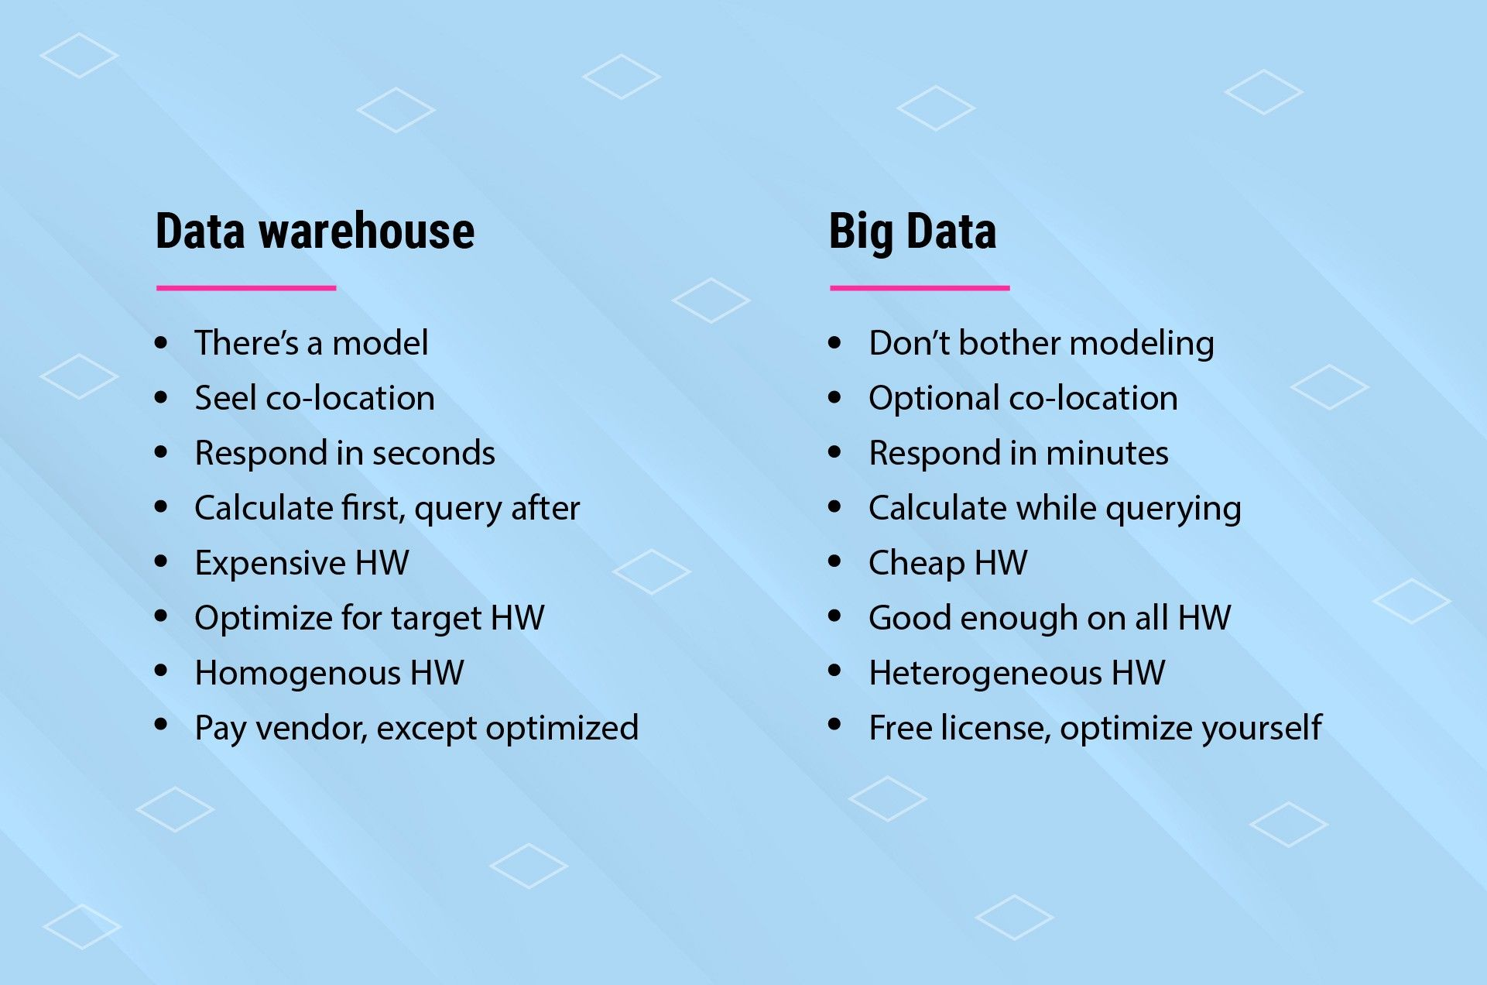

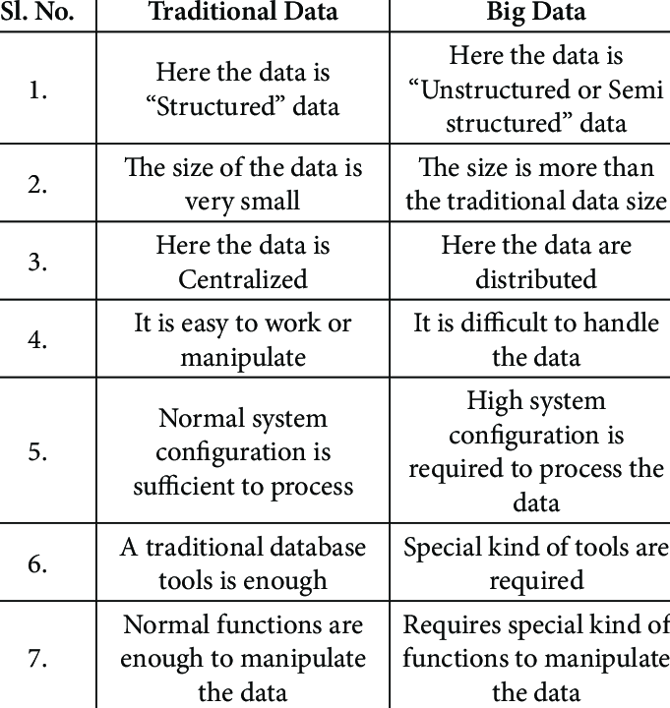

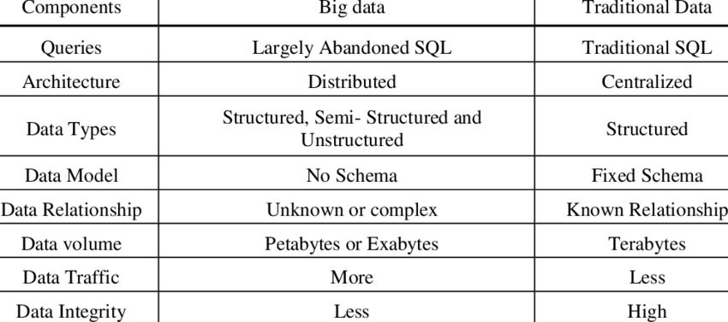

# **What is Hadoop**

Hadoop is an open source framework from Apache and is used to store process and analyze data which are very huge in volume. Hadoop is written in Java and is not OLAP (online analytical processing). It is used for batch/offline processing.It is being used by Facebook, Yahoo, Google, Twitter, LinkedIn and many more. Moreover it can be scaled up just by adding nodes in the cluster.

Modules of Hadoop

1. **HDFS:** Hadoop Distributed File System. Google published its paper GFS and on the basis of that HDFS was developed. It states that the files will be broken into blocks and stored in nodes over the distributed architecture.
2. **Yarn:** Yet another Resource Negotiator is used for job scheduling and manage the cluster.
3. **Map Reduce:** This is a framework which helps Java programs to do the parallel computation on data using key value pair. The Map task takes input data and converts it into a data set which can be computed in Key value pair. The output of Map task is consumed by reduce task and then the out of reducer gives the desired result.
4. **Hadoop Common:** These Java libraries are used to start Hadoop and are used by other Hadoop modules.

## Hadoop Architecture

The Hadoop architecture is a package of the file system, MapReduce engine and the HDFS (Hadoop Distributed File System). The MapReduce engine can be MapReduce/MR1 or YARN/MR2.

A Hadoop cluster consists of a single master and multiple slave nodes. The master node includes Job Tracker, Task Tracker, NameNode, and DataNode whereas the slave node includes DataNode and TaskTracker.

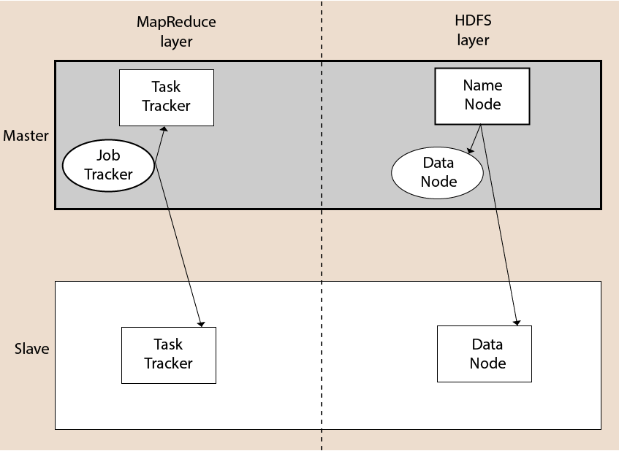

## Spark – Overview

Apache Spark is a lightning fast real-time processing framework. It does in-memory computations to analyze data in real-time. It came into picture as **Apache Hadoop MapReduce** was performing batch processing only and lacked a real-time processing feature. Hence, Apache Spark was introduced as it can perform stream processing in real-time and can also take care of batch processing.

Apart from real-time and batch processing, Apache Spark supports interactive queries and iterative algorithms also. Apache Spark has its own cluster manager, where it can host its application. It leverages Apache Hadoop for both storage and processing. It uses **HDFS** (Hadoop Distributed File system) for storage and it can run Spark applications on **YARN** as well.

## PySpark – Overview

Apache Spark is written in **Scala programming language**. To support Python with Spark, Apache Spark Community released a tool, PySpark. Using PySpark, you can work with **RDDs** in Python programming language also. It is because of a library called **Py4j** that they are able to achieve this.

PySpark offers **PySpark Shell** which links the Python API to the spark core and initializes the Spark context. Majority of data scientists and analytics experts today use Python because of its rich library set. Integrating Python with Spark is a boon to them.